**Command to initialize next.js app**

npx create-next-app nextjs-blog --use-npm --example <https://github.com/vercel/next-learn-starter/tree/master/learn-starter>

* -example will take folder structure of that project

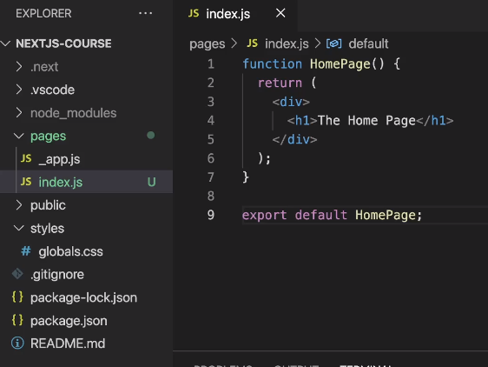

“pages” is the place where all the routing logic lies

“index.js” is the default file that runs

**File name maters**

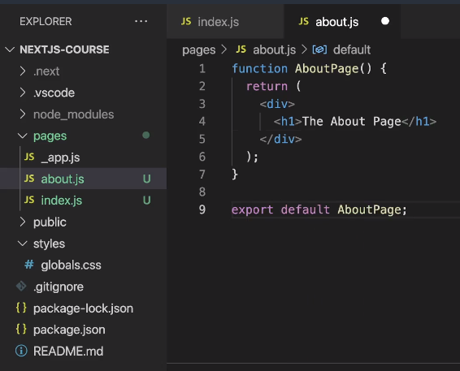

Here “about.js” file is created.

When localhost:3000/about is reached



**We can also structure in the form of folder**

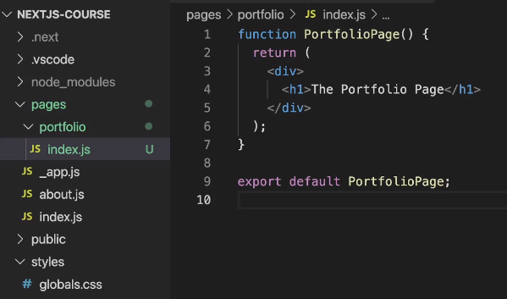

Here when we go to “localhost:3000/portfolio”, then index.js is default and that will run

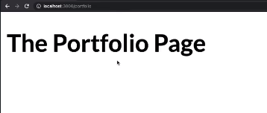

Same could have been done for about.js

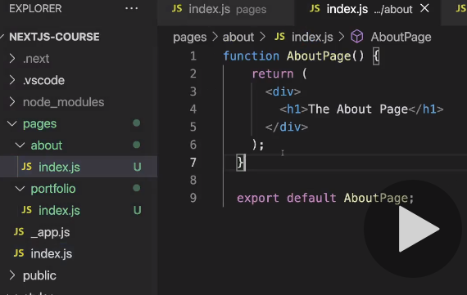

**We can have nested paths too**

Here “list.js” is created under “portfolio” folder

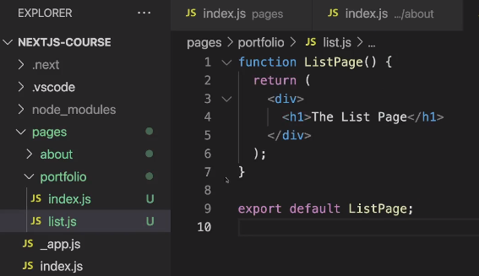

Now when we reach “lh:3000/portfolio/list” this page will be rendered.

**We can have dynamic routing.**

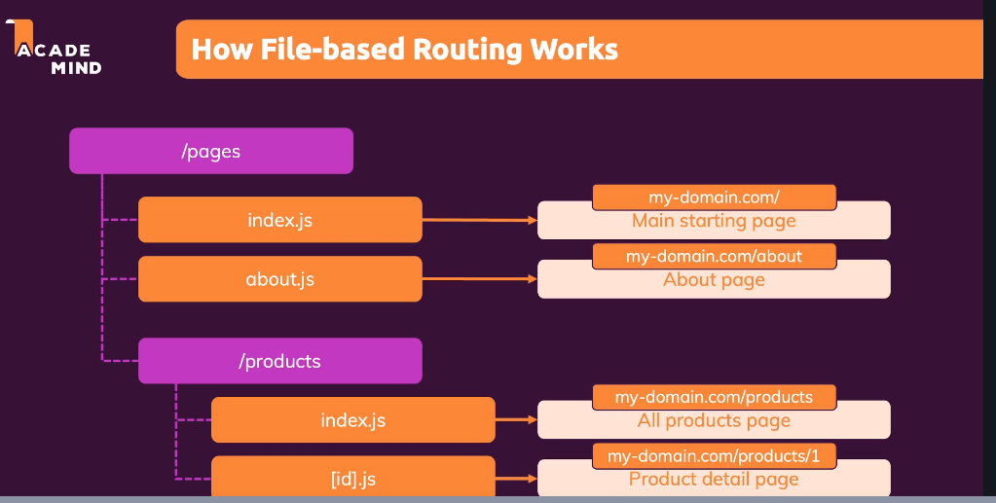

**We have to place the file name inside []**

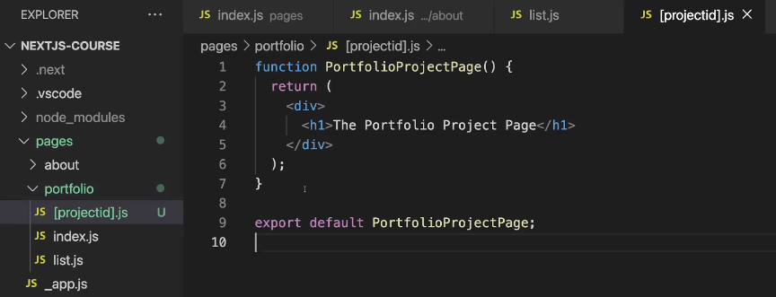

When we reach out to “lh:3000/portfolio/<anything>” this page will run

**How to get that “anything from the URL”**

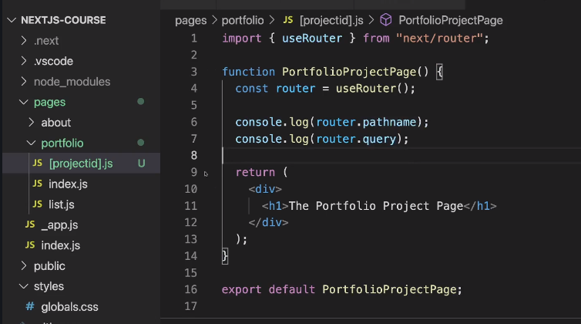 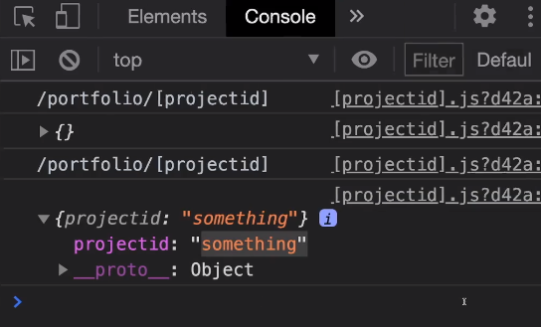

We can use “useRouter” hook that next.js provides

Now “router.query.projectid” will give the url parameter.

**Nested Dynamic Routes**

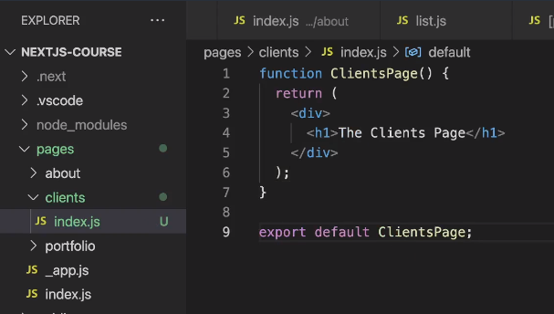

This “index.js” file runs when “lh:30/clients” is requested.

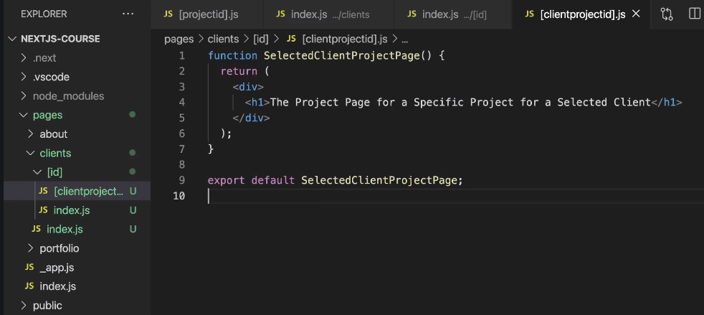

Here we have multiple children.

Inside “clients” folder we have [id] and inside that we have [clientproject].js

This will run for “lh:300/clients/<id>/<anything>

If we run “lh:300/clients/<id>”, then index.js inside [id] folder will run

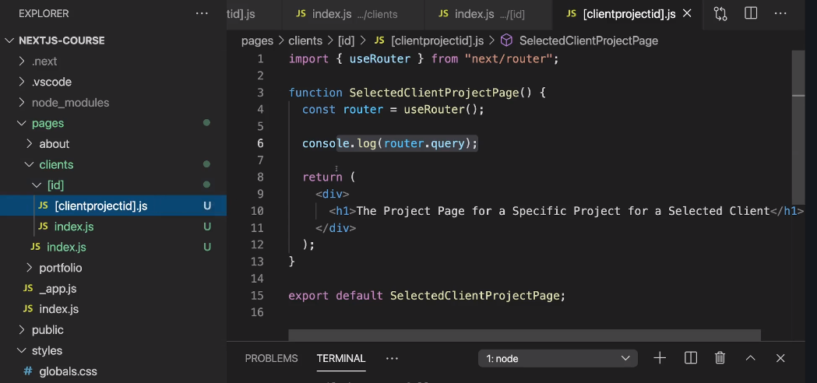

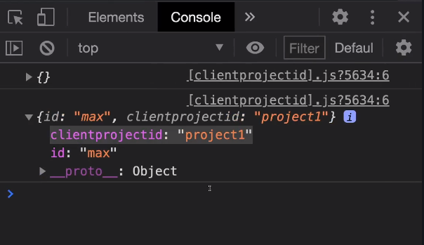

**Catch All Routes ( use … in the file name )**

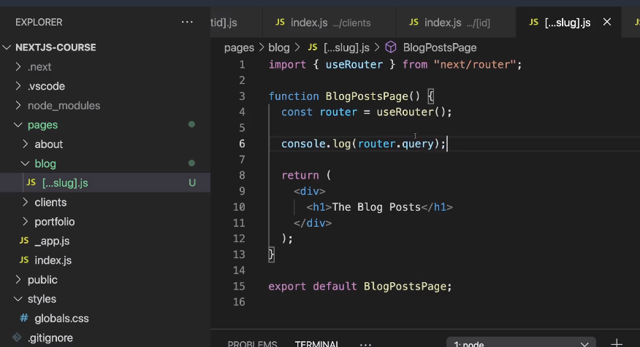

For “lh;30/blog/2012/12”

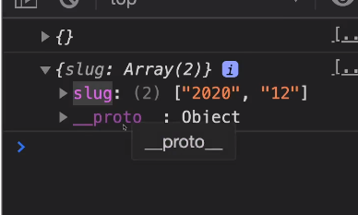

Here we can give any number of params after “blog” in the url. It will work and in router.query it will show those in an array

**Navigating via “Link”**

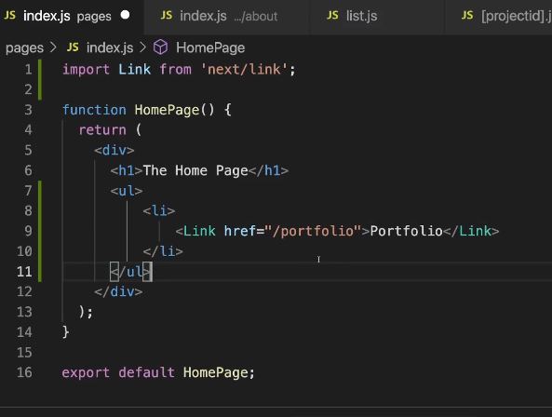

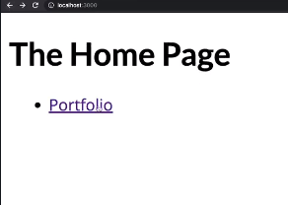

On clicking this link, it will take us to “lh:30/portfolio”

**We can give some props to Link**

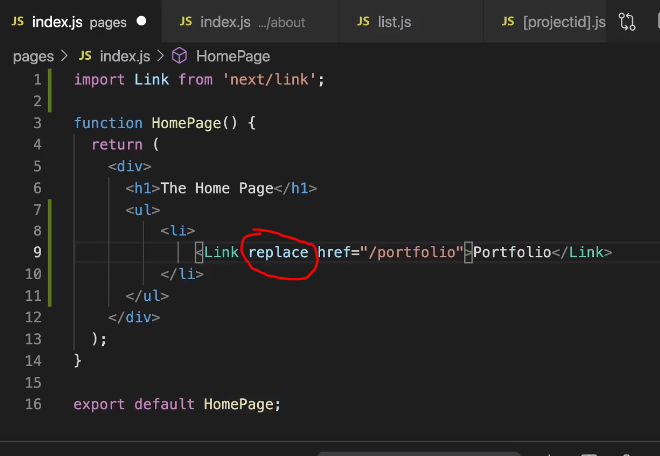

When we give “replace” as props, then page will be replace and **we cannot go back.**

**Other props for link**

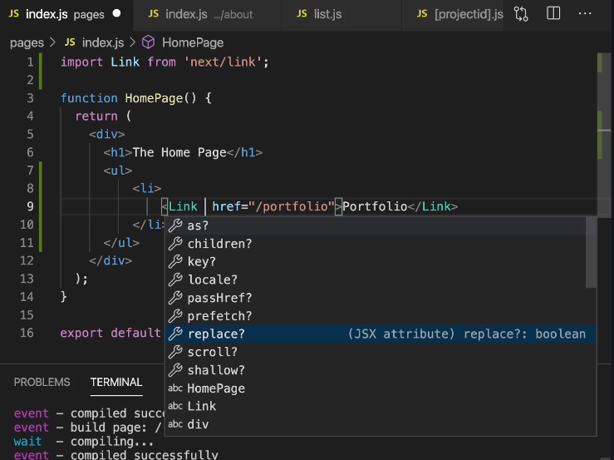

**Going to dynamic routes**

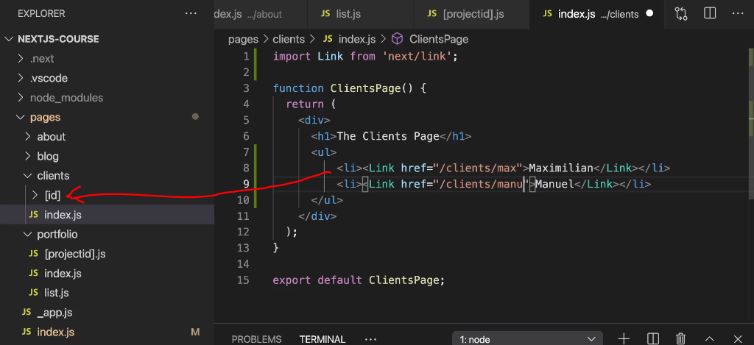

**To create Links dynamically**

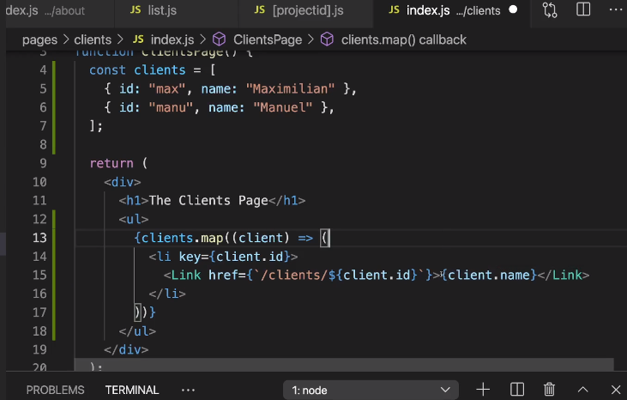



Here Links are generated logically. Not hardcoded.

**Other ways to dynamically create links**

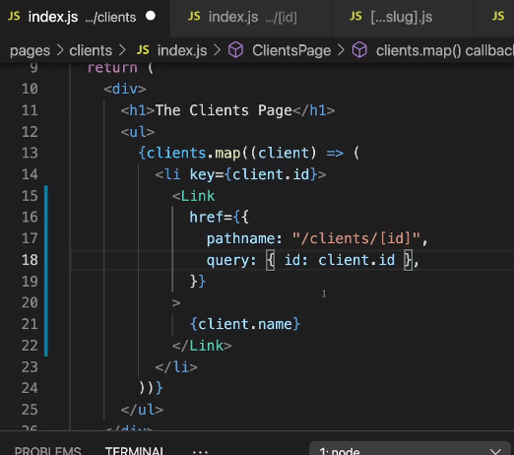

**Going to link programtically ( router.push( url to go ) );**

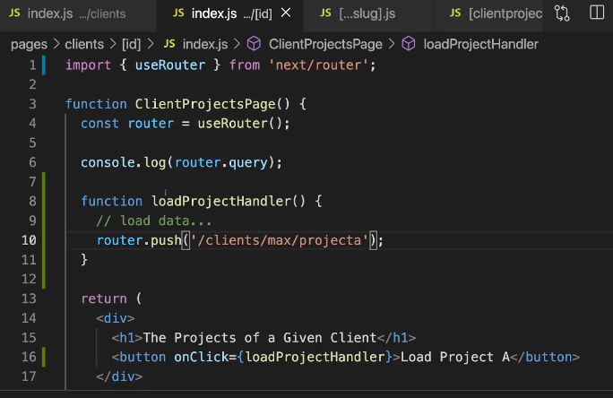

onClick should be used to do something. Inside the we will use

router.push(‘<url to go’);

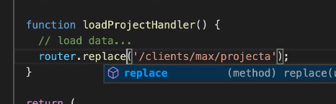

“replace” can also be used.

Other way

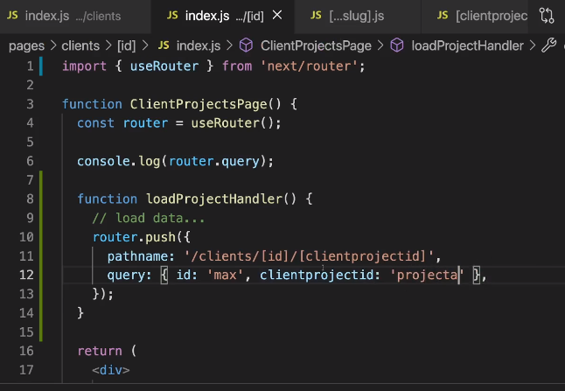

**Page not found**

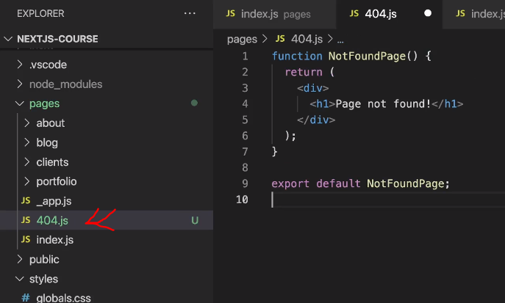

File name should be “404.js”. And it should be under “pages” directly

